FOUNDATION FOR VIRTUAL AND AUGMENTED REALITY SYSTEMS
Lecture23
Lec-23: XR as Interactive Systems
Hello and welcome to the NPTEL MOOC's course on Foundations for Virtual and Augmented Reality Systems. We are going to start a new lecture topic that is Interactive Systems, Usability and XR. So far, we have mostly focused on core concepts related to extended reality, namely the basic ideas, definitions, issues, challenges as well as the hardware and software. Now extended reality systems belong to a broad class of systems that is called interactive systems. So, we cannot learn about extended reality systems without having some basic idea of interactive systems, what these are, what are the core concerns and how to resolve those concerns.
So, essentially in this lecture and subsequent few lectures, What we are going to do is basically try to understand what interactive systems are, how extended reality systems are related to them, what the core concerns of interactive systems are, and accordingly, how we can have better extended reality systems taking into account those core concerns of interactive systems in general. We can start with this famous quote by Mark Weiser. Way back in 1991, which appeared as part of a paper titled The Computer for the 21st Century, published in the Scientific American magazine.
That was way back in 1991, roughly about more than 30 years ago. What did it say? And I quote, is that the most profound technologies are those that disappear. Now what does it mean? It means that when we are talking about a very advanced technology, ideally the technology should not be visible to the user.
The user should feel like dealing with any other item rather than dealing with a specialized technological item. You may try to relate this particular quote with the definition we have discussed earlier about presence. That is, presence means the technological aspect that surrounds the user should disappear from the user's perception. So essentially, both of them refer to the same thing.
That is, we should strive to build systems that do not make it apparent to the user that the user is using some specialized technological product. In fact, in the development of computer systems, people have tried to adhere to this vision, that is, tried to make the technology disappear from the user's point of view. We can understand this if we follow the historical progression of the technological development in this particular field of computers. This is the earliest computer, as we all know.
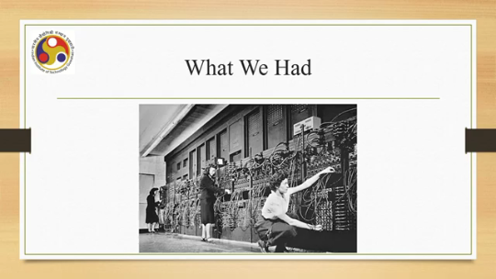
It used to occupy a huge room with lots of wires, and programming referred to the idea of reconnecting the wires, and it used to be accessible only to a very few select people. Then from there, where we are now can be defined with the popular technological products such as wearable devices, mobile devices, flexible devices, as well as connected devices. Now we are surrounded by computers, which are connected to each other.
You must have heard of the terms IoT or ubiquitous computing. So, each user can have access to multiple computers that are connected to each other and can communicate with each other so that the user does not have to separately operate them. So, this is, in a way, marching toward the goal of making the technology disappear. Now, whatever devices that we are using nowadays, whatever systems that we are using nowadays, are examples of interactive computing systems or interactive systems, in short, where interaction takes place between
the computer or the system and the user. One thing to note here is that the user here is a lay person or a layman user. They are not necessarily experts in the technology that is being used to get the experience. So, they are not technology experts; they are lay persons who just want to use the system rather than want to understand how the system works. Now, that is very crucial from the point of view of system development.
Why? Is it necessary for the users to know about the technology behind? So, when you are saying that you are trying to build an interactive system to be used by lay persons who need not be technology experts, are you assuming or do we need to assume that the users should understand the technology behind that particular system? Let us take one interesting example.
The screen here shows you a message, a message printed when somebody, some user, was interacting with a computing system. It shows an error message, a system error message, with some status code; the code appeared in hex format which says that the security accounts manager initialization failed because a device attached to the system, is not functioning. Click OK to shut down and reboot into safe mode. Check the event log for more details. So, some terms are there: event log, security accounts manager. System not functioning, safe mode.
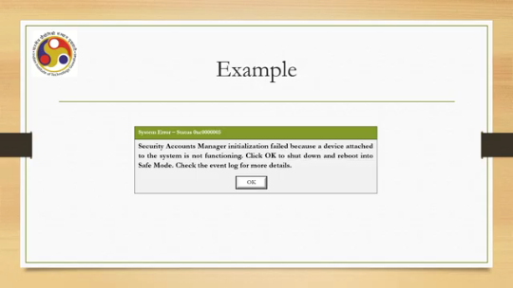
Now, these are terms which ideally we should not expect an end user, a layperson who is not necessarily an expert in the technology behind, to understand or act upon. Similarly, this error code printed in hex format, hexadecimal format, that is also something which is generally incomprehensible to a layperson. So, when there is some error, if we show this type of message to the user, does it serve any purpose? Because the user is not likely to understand anything except to basically click the OK button.
Now that is the only option given, so anyway the user will do that. But if we show such messages, what will happen? That type of message, which the user is likely to fail to understand, can potentially make the user anxious. Did I do something wrong? How to get out of it?
Should we refrain from performing any more things? Here, I or we refers to the user, of course. So when the user becomes anxious, these types of questions may come to his or her mind. What is wrong here? Did I do something wrong?
How can I get out of it? Note that the previous error message did not say anything about how to get out of it. Or what exactly is the wrong thing I did because it is couched in technical jargon which is unlikely to be understood by laypersons. Most importantly, this may make the user refrain from using the system further. Users may always think that if I do this, then it may lead to wrong results and this type of message may appear that may damage the system.
So, let us better not use it. And that is what will defeat the whole purpose of having the system in the first place. So it may lead to loss of motivation for further use. Therefore, we can conclude that designers of interactive systems should not force users to learn about the underlying technology. So when we are dealing with
interactive systems supposed to be used by laypersons, we should not design a system that forces the user to learn the underlying technology or understand the relevant technical terms. This brings us to the user-centric approach, which is generally recommended for building interactive systems. This is the process to design computer systems in which the users' needs and expectations are taken care of by considering their characteristics. So essentially, in a user-centric approach, we start by understanding the user characteristics, what they need, what they expect, and based on that, we come up with the design of the system. Now this leads to several things such as designing the interface elements, the elements with which the user interacts that are acceptable to the users.
Design the layouts, that is, the way the elements are organized on the screen or on the interface, that meet the user's expectations. Help the user perceive the system state, what exactly is happening from the point of view of the user, not from the point of view of technical details, and also design interactions that fulfill the needs of the users by taking them to the desired system states. So, essentially, what the user wants is to get some work done; that means from one state to another they have to transition until they reach some goal state. So, we need to have properly designed interactions that allow the user to easily transition to the goal state.
So, design elements that are acceptable, design layouts that meet user expectations, help the user perceive the state, and take the user to the desired state through carefully designed interactions. These are key characteristics of any user-centric approach. Now, this brings us to another definition. So, you should be mindful of this definition as well, along with the definitions that we have covered earlier related to XR.
Now, this is the definition of human-computer interaction or HCI. It is a discipline concerned with the design, evaluation, and implementation of interactive computing systems for human use and with the study of major phenomena surrounding them. So, when we are dealing with the design and implementation of any interactive system, such as virtual reality systems or augmented reality systems, we should be mindful of this definition, which is the definition of human-computer interaction, which talks about a discipline that deals with the design, evaluation, and implementation of Interactive computing systems for human use.
Here the term human is important. Earlier we talked about laypersons. Essentially, they refer to the same thing. Human use and also the major phenomena surrounding the development of such systems. So, this definition was by ACM
SIGCHI. The official body that deals with computer human interaction. So, all this discussion and definition leads to the core concern. What is the core concern? That is incorporating humans into the design.
So, we should always start by understanding the user and then incorporate their characteristics into the design so that they are able to satisfy, the design is able to satisfy the core concerns that we have listed earlier. So, this brings us to the important issue of human factors. So, why should we talk about human factors here? Now, we wish to design for the layman users or laypersons.
That requires us to first know who they are and secondly why to bother about such characterization. We can try to understand why to bother and who they are in terms of And why to know about them and why to bother about such knowledge in terms of one example. Let us try to understand the nature of the users and its importance with an example. Let us consider someone who wants to perform railway ticket booking.
That person can be a traveler or an agent. Either role is okay for our purpose. Now, when we are talking about a traveler or an agent on behalf of a traveler trying to book a railway reservation ticket, what is the user expected to do? Minimum things that are expected are: input the station name, check the availability of
trains and tickets based upon the check result, book tickets and finally make the payment to the railway. So, these are the basic things, minimum things that are required to be done by the user. Now consider a database manager, database management system administrator, DBMS administrator or manager who performs database querying to get the same information from the railway database. So, on the back side there is the database to get to know the trains, the ticket availability between stations. The database administrator can access the railway database and perform the same thing.
The question is, is this user that is the database administrator performing totally different things than the earlier one that is a traveler or agent? Technically, from a pure technical point of view, both are performing the same work at a very broad level. Now, that work relies on the railway database which is there, both query the database, maybe by different means; both retrieve the information again through different ways; and both use the information again in different ways. It is obvious that the expectations for a traveler or an agent
of how to retrieve the information and how to use it are different in comparison to the database administrator. Also, the need is different. Clearly, unlike a database administrator, a traveler or an agent may not be conversant with the querying language. how to get the information using the query language. So, they require a different sort of interface to provide input, a different sort of interface to see the outcome, and a different sort of interface to act based on the outcome.
as compared to what a database administrator can do with the knowledge of query languages and other technical expertise, technical skills. So, if we are making the system, we first need to know whether we are making it for the traveler or for the database administrator, and accordingly we can have the system designed. For a traveler, we need to have a different system as compared to a design that is required for a database administrator. So, the first thing is that we need to know the users. So, this is why through this example, probably
you may have understood why it is important to know the user and also how the knowledge can help. Now, the thing is that we need to know the user, but that is easier said than done. How can we do that? So, let us focus on that in the next part of the lecture. So, if we quickly summarize.
In this part of the lecture, what we have learned is an overview of interactive systems and key concerns. What are the key things? That is, know the user and knowledge of the user, user characteristics, and using that knowledge to build the system. Those are the key concerns. So, partly we have tried to understand these concerns. And in the next part of the lecture, we will continue this discussion and try to understand how we can know the user and how we can utilize the information.
So, see you again in the next part of the lecture. Thank you and goodbye. Happy learning.

